**INDUSTRY: AEROSPACE INDUSTRY**

**DEPARTMENT: CRUCIAL PAIN POINTS OF ORGANISATION**

* **INTRODUCTION**:
* WHAT?

Aerospace industry, assemblage of manufacturing concerns that deal with vehicular flight within and beyond Earth’s atmosphere. (The term aerospace is derived from the words aeronautics and spaceflight.

* WHY ?

The aerospace industry is a complex and dynamic sector that faces a number of crucial pain points that can affect the performance and competitiveness of organizations within this industry. These pain points can cause significant challenges and difficulties for organizations in the aerospace industry, and addressing them is critical for success.

Some of the key reasons why these pain points are crucial include:

**High Stakes**: The aerospace industry operates in a highly regulated environment with strict standards for quality, safety, and reliability.

**Competition**: The aerospace industry is highly competitive, and companies must continually innovate and improve to remain competitive and win business.

**Complexity**: This complexity can make it difficult for organizations to keep pace with new developments and manage their operations effectively.

**Cost Pressures**: The aerospace industry is characterized by high production costs, and companies must find ways to reduce costs while maintaining high standards of quality and safety.

**Technological Advancements**: The aerospace industry is constantly evolving, and companies must stay ahead of the curve in terms of technology and innovation to remain competitive.

* **BY WHOM?**

The aerospace industry serves a wide range of stakeholders, including:

**Customers**: The aerospace industry produces a variety of products and services, including commercial and military aircraft, satellites, and launch vehicles, which are used by a variety of customers, including airlines, military organizations, and governments.

**Employees**: The aerospace industry is a major source of high-tech jobs, and employs a wide range of workers, including engineers, designers, production workers, and support staff.

**Suppliers**: The aerospace industry relies on a complex and global supply chain, and works with a variety of suppliers to obtain raw materials, components, and other products and services.

**Investors**: The aerospace industry is a significant source of investment opportunity, and is of interest to a wide range of investors, including individual investors, institutional investors, and venture capitalists.

**Regulators**: The aerospace industry is subject to a wide range of regulations, and works with various regulatory agencies, including the Federal Aviation Administration (FAA) and the European Aviation Safety Agency (EASA), to ensure compliance with industry and government regulations.

**Communities**: The aerospace industry can have a significant impact on local communities, both in terms of job creation and economic development, and in terms of environmental impact.

**Society**: The aerospace industry plays a critical role in shaping the world we live in, from facilitating global travel and communication to enabling scientific discovery and exploration.

* **GENERAL VIEW**:

Aerospace organizations are in dire need of science, technology, and engineering talent to continue to support future growth. Talent Management ,Finding Growth Opportunities ,Global Integration ,Profitability & Cost Pressures ,Better Program & Project Management these are the pain points as in the general view.

* NATIONAL WIDE PROBLEMS:

Large-scale data requirements : The computing power required to model global, multi-tier supply chains and explode demand and supply across integrated supply chains is enormous. But the ability to scale is a critical capability to supply chain success.

Supply chain complexity

Limited visibility due to increased supply chain complexity makes it difficult to see the true reality of the extended value network when it comes to capacity, material availability and the likelihood of supporting schedule shifts.

* INTERNATIONAL PROBLEMS:

1. **Developing a Sustainable Supply Chain**

The time it takes for materials to get to specific warehousing facilities or the shop floor determines how quickly orders can be fulfilled. An inadequate internal supply chain management strategy within the shop floor can also lead to delays and downtime. Today, the ongoing digital transformation provides the tools needed to capture supply chain data while IOT platforms have the computing resources needed to receive insight from supply chain data.

2. **Government Regulations and Environmentally-friendly Policies**

The need for controlled emission rates during manufacturing processes and the demand for more efficient engines and propulsion equipment are factors that must be considered when manufacturing equipment for the aerospace and defense industry. It’s imperative that aerospace and defense OEMs design innovative equipment that supports the drive to reduce emission rates from the factory floor and the engines used within the industry.

To develop sustainable operational strategies and to improve the efficiency of manufacturing equipment on the shop floor, there needs to be an understanding of how operators use this machinery. This is where IOT solutions and their ability to track machine utilization, throughput, and emission rates come into play. The captured data and insight from monitoring deployed equipment will then provide the information needed to develop equipment that meets specified government regulations.

3.**Growing Revenue in A Competitive Environment**

The aerospace and defense industry is dominated by the trifecta of Boeing, Airbus, and Lockheed Martin. The big 3 are responsible for the majority of the business or contracts aerospace and defense OEMs get which leads to fierce competition and industry rivalry.

Seeking an edge over the competition requires delivering more value in addition to producing equipment. The acceptance of Industry 4.0 means the big 3 and other stakeholders require equipment that supports data extraction and other value-added services that simplify their manufacturing operations. IIoT solutions enable data capture while IIoT platforms provide the resources for storing and analyzing shop floor data. Benchmark analysis on machine utilization.

<https://www.machinemetrics.com/blog/major-challenges-aerospace-and-defense-manufacturers>

* **PROS** 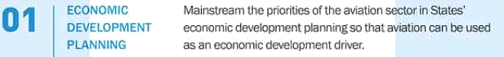

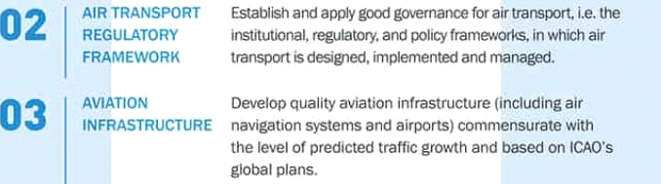

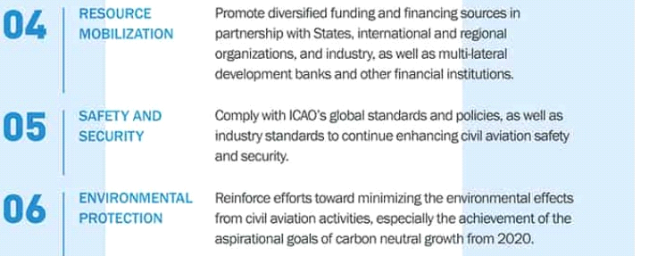

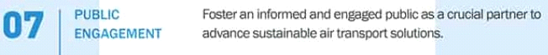

* **CONS**

Aircraft engines produce gases, noise, and particulates from fossil fuel combustion, raising environmental concerns over their global effects

and their effects on local air quality.Jet airliners contribute to climate change by emitting carbon dioxide (CO2), the best understood greenhouse gas, and, with less scientific understanding, nitrogen oxides, contrails and particulates. Their radiative forcing is estimated at 1.3–1.4 that of CO2 alone, excluding induced cirrus cloud with a very low level of scientific understanding.

**CHALLENGES:**

The crucial pain points of organizations in the aerospace industry can include a range of problems, including:

Cost Control: Controlling costs is a major challenge for organizations in the aerospace industry, as projects often take longer and cost more than initially estimated. This can put significant financial pressure on companies and limit their ability to invest in new projects and technologies.

Time-to-Market: The aerospace industry is highly competitive, and companies are under pressure to bring new products to market quickly in order to stay ahead of the competition. This can create significant challenges for organizations, as they must balance the need for innovation and rapid development with the need to ensure safety, quality, and compliance with regulatory requirements.

Complexity: The aerospace industry is highly complex, with many interconnected systems and components that must work together to produce safe and reliable products. This complexity can create significant challenges for organizations, as they must manage the design, development, and manufacture of complex systems in a highly regulated and competitive environment.

Talent Retention: The aerospace industry is facing a talent shortage, as a significant number of experienced workers are retiring and a new generation of workers is needed to take their place. This can create challenges for organizations, as they must find ways to attract and retain the talent they need to remain competitive.

Regulation: The aerospace industry is heavily regulated, with strict rules and standards governing the design, manufacture, and operation of aircraft and other aerospace products. This regulation can create challenges for organizations, as they must navigate a complex and constantly changing regulatory environment while also ensuring that their products are safe, reliable, and compliant with all relevant standards.

Supply Chain Management: The aerospace industry is highly dependent on a complex and global supply chain, with components and materials often sourced from around the world. This can create challenges for organizations, as they must manage the flow of goods and materials across the supply chain while also ensuring quality, consistency, and compliance with all relevant regulations and standards.

Environmental Concerns: The aerospace industry is facing increasing pressure to address environmental concerns, including the impact of aviation on climate change, air and noise pollution, and the depletion of natural resources.

**PROBLEM CHOOSEN:**

**Supply Chain Management (SCM)**

The aerospace industry relies heavily on a complex and global network of suppliers to provide the raw materials, components, and sub-assemblies needed to manufacture aircraft and aerospace products. Managing this supply chain effectively is critical to the aerospace industry’s success, but it also presents a number of challenges.

[**https://radiantrfid.com/blog/aerospace-supply-chain-challenges**](https://radiantrfid.com/blog/aerospace-supply-chain-challenges)

**LOOPHOLES**

There are several potential loopholes or challenges in supply chain management, including:

**Lack of Visibility**

**Supplier Dependence**

**Quality Control Issues**

**Compliance Challenges**

**Disruptions**

**Data Management**

**Cultural Differences**

**Ineffective relations**

**PROBLEM STATEMENT:**

INEFFECTIVE RELATIONSHIP MANAGEMENT WITH SUPPLIERS

EFFECTS:

**Increased Costs**

**Decreased Speed to Market**

**Reduced Quality**

**Compliance Challenges**

**Supplier Dependence**

**Disruptions**

**Reputation Damage**

[**https://www.invoicera.com/blog/top-10-challenges-faced-in-buyer-supplier-relationship-management**](https://www.invoicera.com/blog/top-10-challenges-faced-in-buyer-supplier-relationship-management)

**WHY HEALTHY RELATIONS?**

Having great suppliers as part of your business improves both your service to your customers as well as your efficiency.A good relationship with a supplier can also provide you with a much-needed business supporter who can provide a fresh perspective and encourage business to come your way.After all, if your business is growing, so will your suppliers’ business.To maintain a great supplier relationship, you have to approach it in the right way.

**SOLUTIONS**

**1. Be proactive**

**2. Communicate regularly and effectively**

**3. Establish roles and responsibilities and remember them**

**4. Understand the contractual obligations**

**5. Behave ethically and honestly at all times**

**6. Regularly review the deliverables and performance**

**7. Identify and monitor risks**

**8. Seek professional advice**

**9. Be reasonable and fair**

**10. Establish the basis of the working relationship**

[**https://www.grosvenor.com.au/10-tips-to-improve-supplier-procurement-relationships**](https://www.grosvenor.com.au/10-tips-to-improve-supplier-procurement-relationships)

**OUTCOME STATEMENT:**

To improve supplier relationships and optimize the supply chain, our organization will implement clear communication protocols, foster collaboration, implement performance metrics, develop long-term relationships, regularly review relationships, address issues quickly, and provide support and training to suppliers. As a result, we will reduce costs, increase speed to market, improve product quality, maintain compliance, reduce supplier dependence, minimize disruptions, and enhance our reputation in the aerospace industry.

**FEATURE CREATION**

* TRANSACTIONAL MINDSET
* PERFORMANCE MANAGEMENT
* RESPECTING DEADLINES
* CUSTOMER RELATIONSHIPS
* QUALITY
* ACCESSIBLITY
* LEADING TIME
* PRICING
* RISK MANAGEMENT
* COMMUNICATION
* TRANSPORTATION
* BACKWORD INTEGRATION
* EXPECTATIONS
* ACCOUNTING TOOLS
* DELIVERY TIMINGS

**FEATURE SELCETION**

* QUALITY
* ACCESSIBILTY
* MEETING EXPECTATION
* COMMUNICATION
* RESPECTING DEADLINES
* PRICING

**FEATURE EXTRACTION**

**COMMUNICATION:** CUSTOMER RELATIONSHIPS

LOGISTICS

**QUALITY:** PERFORMANCE MANAGEMENT

**PRICING**

**RESPECTING DEADLINES:** DELIVERY TIMINGS

**ACCESSIBILITY**

**MEETING EXPECTATIONS**

**FEATURE TRANSFORMATION**

**COMMUNICATION:** 1-4(1-INEFFECTIVE, 2-GOOD, 3-EFFECTIVE,4-VERY EFFECTIVE).

**QUALITY:** 1-10(RATING).

**PRICING:** 1-4(1-NOT AFFORDABLE, 2-AFFORDABLE, 3-BUDGET FRIENDLY,4-CHEAPER).

**RESPECTING DEADLINESS:** 1-7(1-ON DATE,2-6:DELAYED BY(MINUTES,HOURS,DAYS,WEEKS,MONTHS)7-NOT DELIVERED).

**ACCESSIBILITY:** 1-5(1- REACHABLE,2-VIA MESSAGES,3-USING CALLS,4-EMAILING,5-NOT REACHABLE).

**MEETING EXPECTATIONS:** 1-4(1-APPRETIATIVE, 2-APPLAUSABLE, 3-ACCEPTABLE,4-UNACCEPTABLE).

**CODE:** 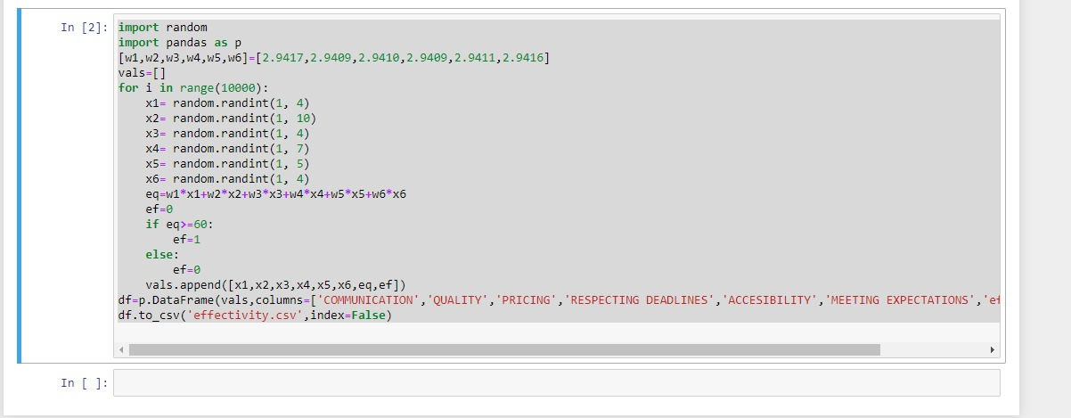

**MODEL:**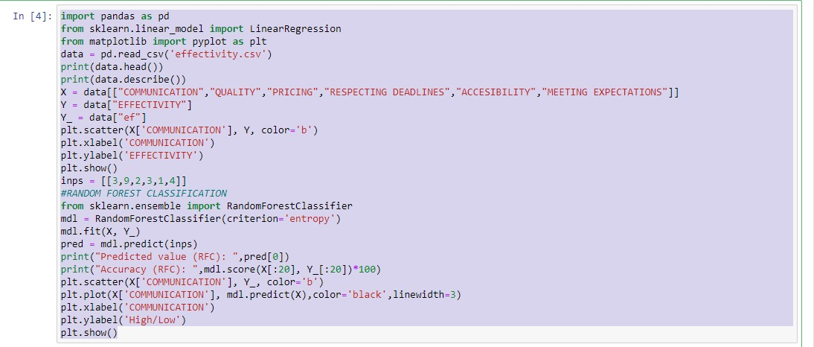 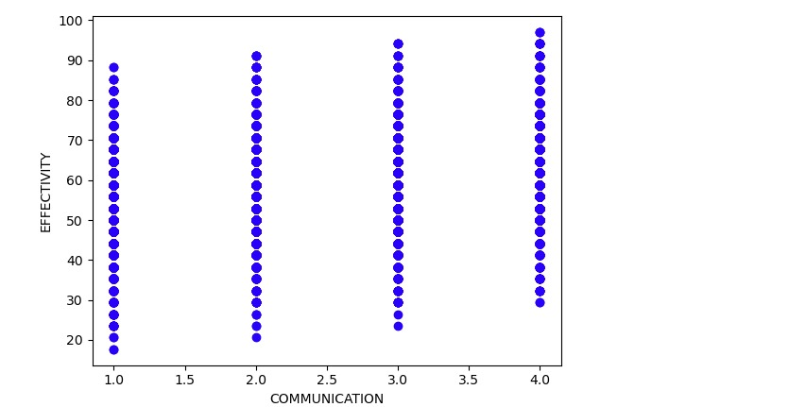

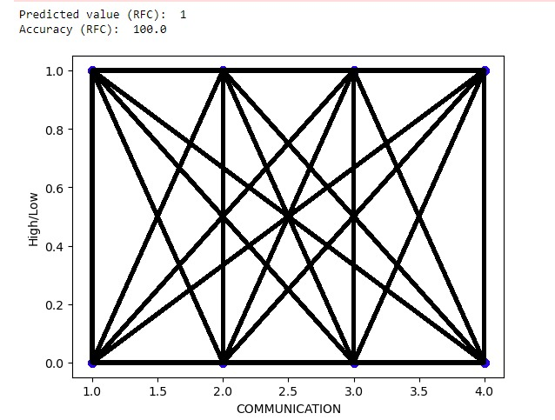

**Reasons for selecting random forest as a data model**:

* Works well with non-linear data.
* Lower risk of over fitting.
* Runs efficiently on a large dataset.
* Better accuracy than other classification algorithms.
* Interpretability.
* Less Data Preparation.
* Non-Parametric.
* Less complexity.
* Versatility (adaptability).
* Simple to understand for coders.
* Can fix more features.

**Reasons for not preferring cluster algorithms:**

* It requires grouping. Thereby it is a long process.
* Grouping may accurate or not. It is indefinable.
* It needs lot of input data.
* Complexity is high.
* Different methods give different results.

**To support our data...we prove by:**

1. By reviews from airline organization.
2. By collecting random as well as dependent data and checking the outcomes.
3. By confusion matrix.

* BY REVIEWS

Aero Mongolia

3.0

<https://www.tripadvisor.in/Airline_Review-> d13804006-Reviews-Aero-Mongolia

I received an email about 3 days ahead of our flight telling us that they had decided to move the flight one day ahead.

Air Bagan

3.0

<https://www.tripadvisor.in/Airline_Review-d10533085-Reviews-Air-Bagan>

Great little airline.. they do the most with what they have. Did not experience any delays. Check in process was a little disorganized but ok.

The aerospace industry relies heavily on a complex and global network of suppliers to provide the raw materials, components, and sub-assemblies needed to manufacture aircraft and aerospace products.

Aerolineas Argentinas

4.0

<https://www.tripadvisor.in/Airline_Review-d8728988-Reviews-Aerolineas-Argentinas>

Only reason we went with Aerolineas Argentinas is because it is basically the only airline that was flying to our destination.

Air India Express

2.5

https://www.tripadvisor.in/Airline_Review-d8729194-Reviews-Air-India-Express

Very disappointed with my journey with Air India Express. Out of all my travels I've never experienced such terrible communication and information.

Alsie Express

5.0

<https://www.tripadvisor.in/Airline_Review-d11831130-Reviews-Alsie-Express>

I have flown with these guys twice before and each time was one of my most pleasant flight experiences. The airplane has ample legroom, cabin service is great, it lets you know what commercial flying could be like.

* BY COLLECTING RANDOM AS WELL AS DEPENDENT DATA SETS:

We found out after collecting the random as well as dependent data resulted in similar outcome that is the efficiency and accuracy.

When the data is massively fittable the accuracy will be more.

* BY CONFUSION MATRIX**:**

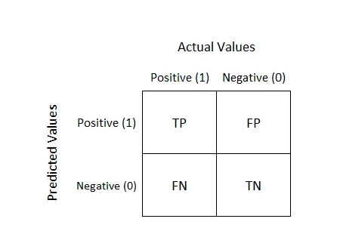

**TP-** predicting positive and actuality is true.

**FP-** predicting positive and actuality is false.

**FN-** predicting negative and actuality is false.

**TN-** predicting negative and actuality is true.

[**https://www.analyticssteps.com/blogs/what-confusion-matrix**](https://www.analyticssteps.com/blogs/what-confusion-matrix)

1. TP-Considering maximum value 4 of communication and predicting efficiency as high(1)

FP-Considering maximum value 4 of communication and predicting efficiency as low(0)

TN- Considering minimum value 1 of communication and predicting efficiency as low(0)

FN- Considering minimum value 1 of communication and predicting efficiency as high(1)

1. TP-Considering minimum value 1 of communication and predicting efficiency as high(1)

FP-Considering minimum value 1 of communication and predicting efficiency as low(0)

TN- Considering maximum value 4 of communication and predicting efficiency as low(0)

FN- Considering maximum value 4 of communication and predicting efficiency as high(1)

1. TP-Considering value 3 in communication and predicting efficiency as high(1)

FP-Considering value 3 in communication and predicting efficiency as low(0)

TN- Considering value 3 in communication and predicting efficiency as low(0)

FN- Considering value 3 in communication and predicting efficiency as high(1)

1. TP-Considering value 4 in communication and predicting efficiency as high(1)

FP-Considering value 4 in communication and predicting efficiency as low(0)

TN- Considering value 4 in communication and predicting efficiency as low(0)

FN- Considering value 4 in communication and predicting efficiency as high(1)

1. TP-Considering value 2 in communication and predicting efficiency as high(1)

FP-Considering value 2 in communication and predicting efficiency as low(0)

TN- Considering value 2 in communication and predicting efficiency as low(0)

FN- Considering value 2 in communication and predicting efficiency as high(1)

1. TP-Considering maximum value 10 of quality and predicting efficiency as high(1)

FP-Considering maximum value 10 of quality and predicting efficiency as low(0)

TN- Considering minimum value 1 of quality and predicting efficiency as low(0)

FN- Considering minimum value 1 of quality and predicting efficiency as high(1)

1. TP-Considering minimum value 1 of quality and predicting efficiency as high(1)

FP-Considering minimum value 1 of quality and predicting efficiency as low(0)

TN- Considering maximum value 10 of quality and predicting efficiency as low(0)

FN- Considering maximum value 10 of quality and predicting efficiency as high(1)

1. TP-Considering value 8 in quality and predicting efficiency as high(1)

FP-Considering value 8 in quality and predicting efficiency as low(0)

TN- Considering value 8 in quality and predicting efficiency as low(0)

FN- Considering value 8 in quality and predicting efficiency as high(1)

1. TP-Considering value 3 in quality and predicting efficiency as high(1)

FP-Considering value 3 in quality and predicting efficiency as low(0)

TN- Considering value 3 in quality and predicting efficiency as low(0)

FN- Considering value 3 in quality and predicting efficiency as high(1)

1. TP-Considering value 5 in quality and predicting efficiency as high(1)

FP-Considering value 5 in quality and predicting efficiency as low(0)

TN- Considering value 5 in quality and predicting efficiency as low(0)

FN- Considering value 5 in quality and predicting efficiency as high(1).

1. TP-Considering minimum value 1 of pricing and predicting efficiency as high(1)

FP-Considering minimum value 1 of pricing and predicting efficiency as low(0)

TN- Considering maximum value 4 of pricing and predicting efficiency as low(0)

FN- Considering maximum value 4 of pricing and predicting efficiency as high(1)

1. TP-Considering maximum value 4 of pricing and predicting efficiency as high(1)

FP-Considering maximum value 4 of pricing and predicting efficiency as low(0)

TN- Considering minimum value 1 of pricing and predicting efficiency as low(0)

FN- Considering minimum value 1 of pricing and predicting efficiency as high(1)

1. TP-Considering value 3 in pricing and predicting efficiency as high(1)

FP-Considering value 3 in pricing and predicting efficiency as low(0)

TN- Considering value 3 in pricing and predicting efficiency as low(0)

FN- Considering value 3 in pricing and predicting efficiency as high(1).

1. TP-Considering value 1 in pricing and predicting efficiency as high(1)

FP-Considering value 1 in pricing and predicting efficiency as low(0)

TN- Considering value 1 in pricing and predicting efficiency as low(0)

FN- Considering value 1 in pricing and predicting efficiency as high(1).